Nithin S
221IT085

IT250 Lab Assignment 5

Q1) Write the Lex Program which will erase all the Comments in the given C program.

CODE

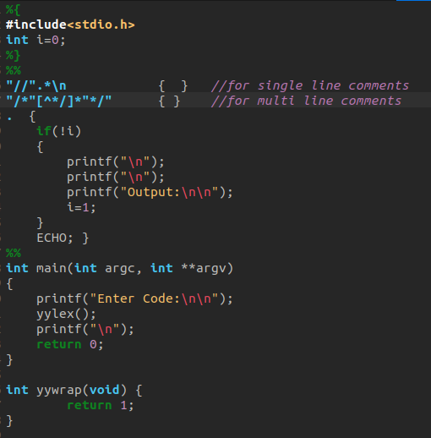

OUTPUT

Test Case 1

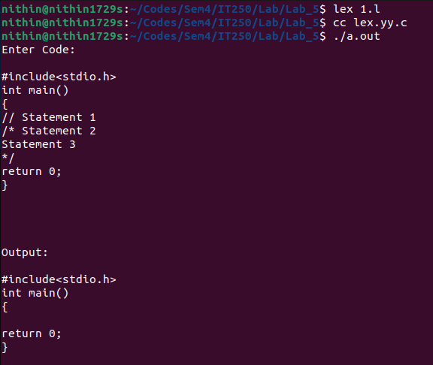

Test Case 2
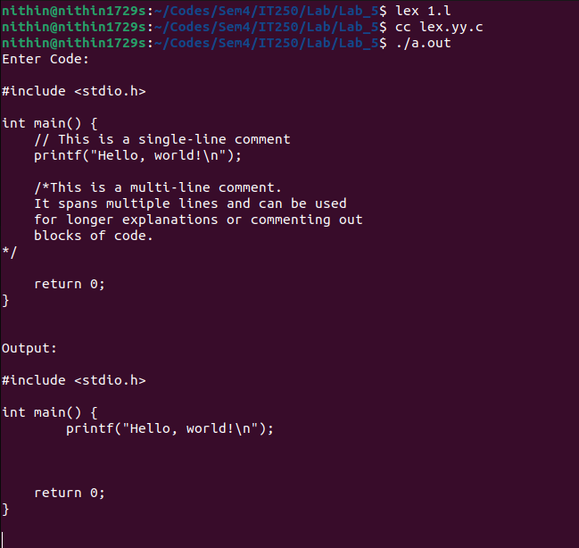

Test Case 3

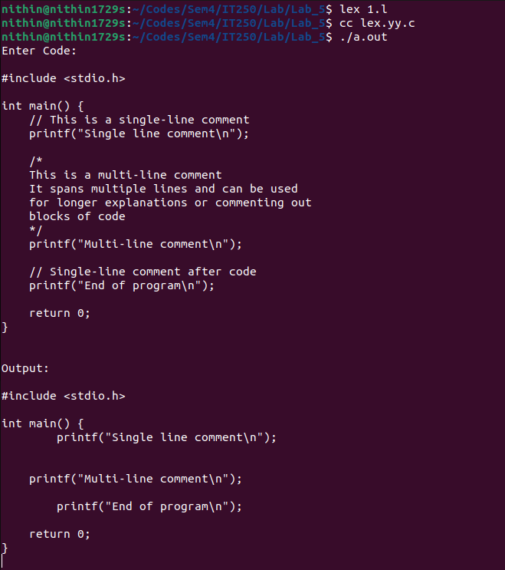

Q2) Write the Lex Program to check the input which is the URL, whether it's valid or not

CODE

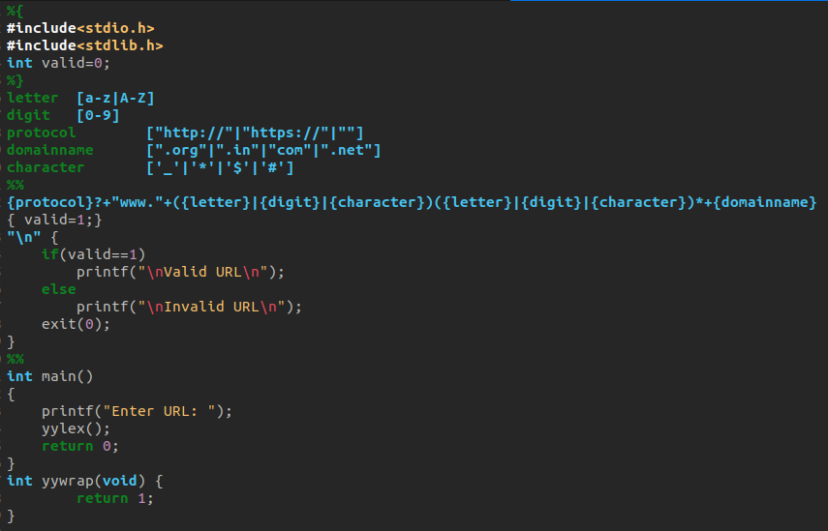

OUTPUT

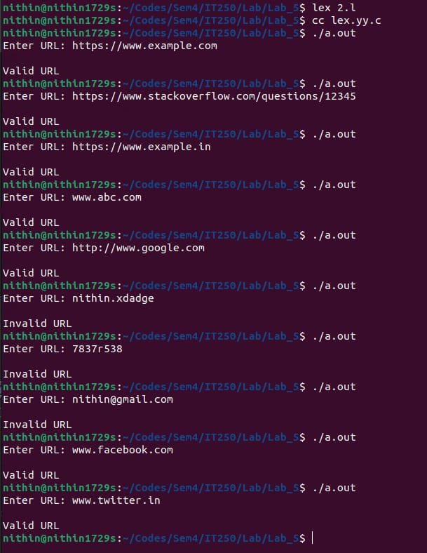

Q3) Write the Lex Program to count all the tokens from the given input file.

CODE

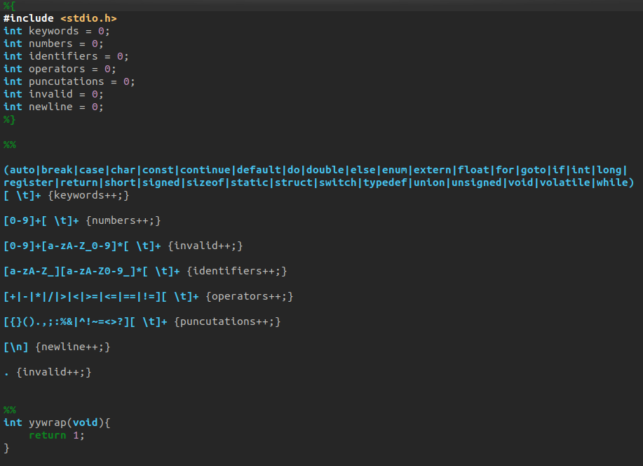
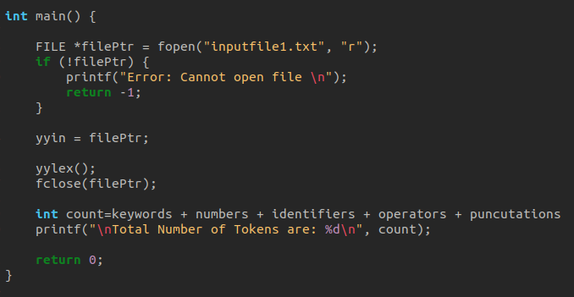

OUTPUT

Test Case 1

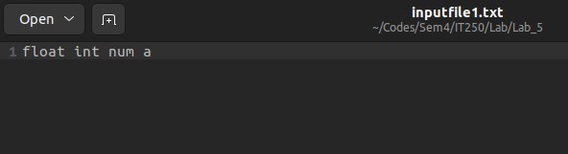
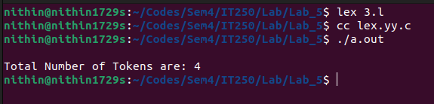

Test Case 2
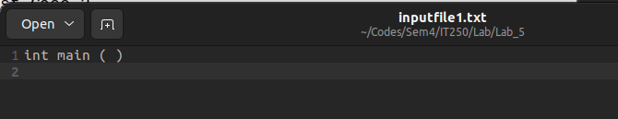
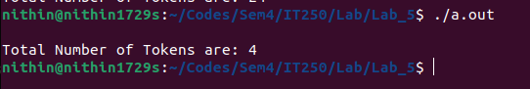

Test Case 3

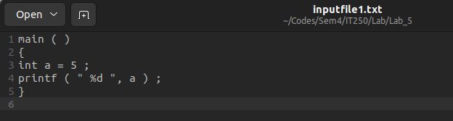

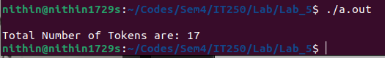

Test Case 4

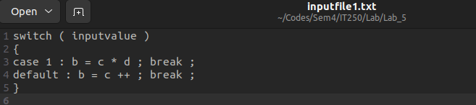

Q4) Write the Lex Program to verify the entered Email is valid or not.

CODE

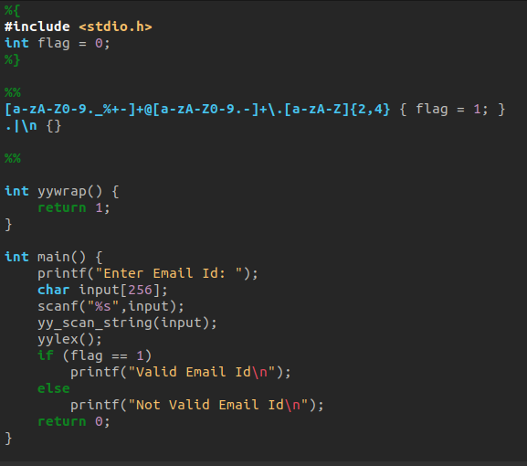

OUTPUT

